Course: CSE 306 – Network Programming
LAB 2 – Python

Student name | Phan Ngoc Hanh Nhi
Student ID | 2131209002

The requirement is to build a Python project for network configuration management, used to store and manage information about network nodes (clients/servers).

REQUIREMENT 1 – WORKING ENVIRONMENT (MANDATORY)
- Create a virtual environment using venv or pipenv
- Activate the virtual environment before running the program
- Install at least one external library (black, requests)
- Export the requirements.txt file
! Do not use Python global

Question: Explain the difference between Python global and Python virtual environments. Why is it necessary to use them?
The Difference:
- Python Global Environment: This is the default, system-level environment for Python. When you install libraries (packages) here, they are shared across all projects and user accounts on the computer.
- Python Virtual Environment: This is an isolated environment that contains an independent copy of the Python interpreter and specific libraries dedicated entirely to a single project.
Why is it necessary to use them?
- Avoid Dependency Conflicts: Suppose Project A needs the requests library version 1.0, but Project B requires requests version 2.0. Virtual environments allow each project to keep the exact library versions it needs without interfering with one another.
- Encapsulation and Reproducibility: A virtual environment allows you to easily export the list of installed libraries into a requirements.txt file. Others (like teachers grading your assignment) can simply use this file to replicate the exact environment configuration needed to run your code.
- System Protection: Not using the Global environment helps prevent your operating system from getting cluttered or running into system errors caused by incompatible library packages (often referred to as “Dependency Hell”). Furthermore, using a virtual environment does not require administrative (sudo/admin) privileges.

REQUIREMENT 2 – PROJECT STRUCTURE
The project must be organized according to the following structure:

lab2_your_computer_ID/
├── .venv/
├── app/
│ ├── models/
│ │ └── node.py
│ ├── utils/
│ │ └── validator.py
│ └── config/
│ └── config_manager.py
│
├── data/
│ └── nodes.json
│
└── main.py
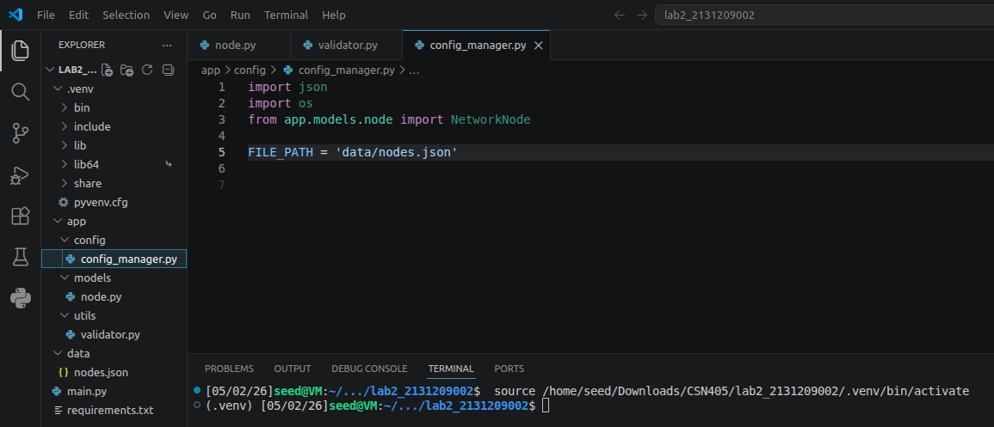

REQUIREMENT 3 – DATA MODEL (OOP)
Create a NetworkNode class (node.py) with the following information:
- node_id (automatically generated)
- ip
- port
- role (client or server)
- protocol (TCP or UDP)
Constraints:
- The IP address must be valid.
- The port must be between 1 and 65535.
- The role must only accept either client or server.
- Invalid data will result in an error (Exception).
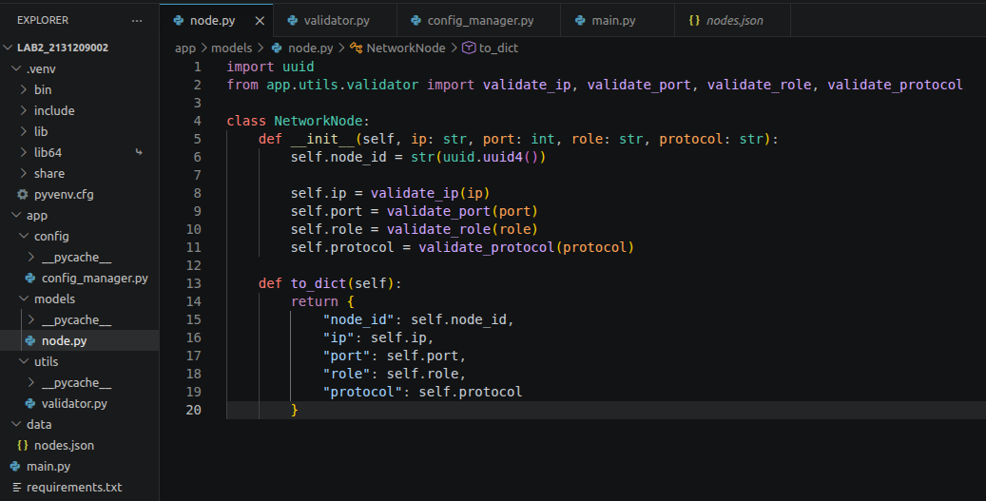
REQUIREMENT 4 – DATA VALIDATION
Write a separate module (validator.py) to check:
- IP (valid IPv4 address)
- Port
- Role
- Protocol (only TCP or UDP)
- Do not print errors to the screen
- Errors must be handled using Exceptions
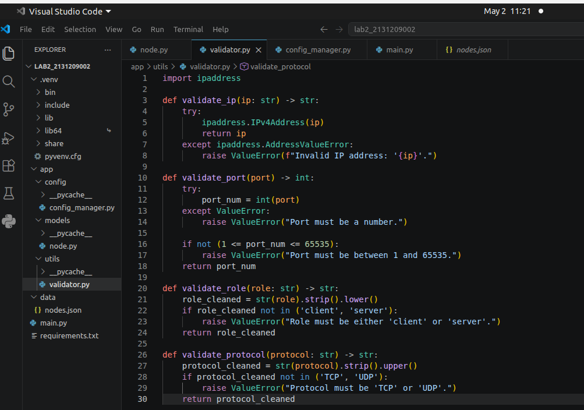
REQUIREMENT 5 – CONFIGURATION FILE MANAGEMENT
- (config_manager.py) Save the list of nodes to the file data/nodes.json
- Read node data from the file
- Support:
- Add nodes
- Delete nodes by node_id
- Display the list of nodes
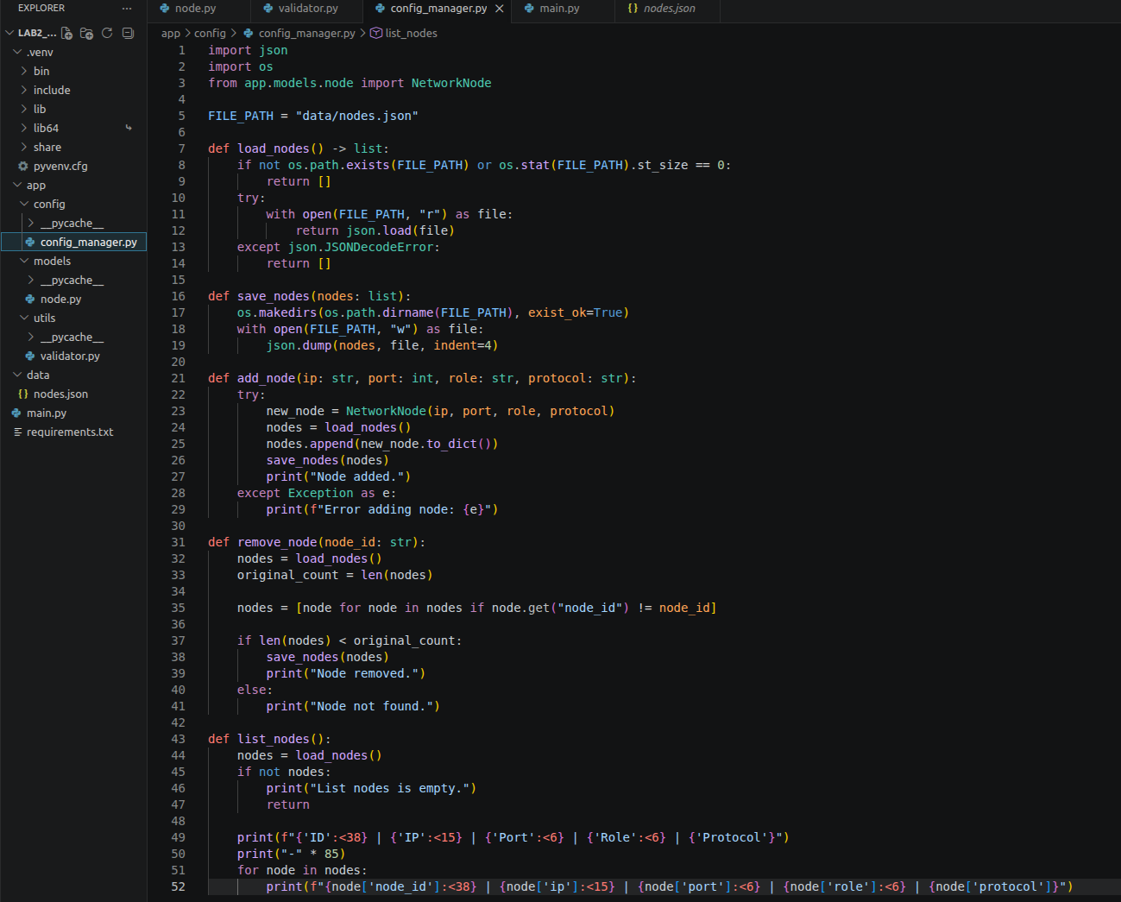

REQUIREMENT 6 – MAIN PROGRAM (CLI)
When the program runs (main.py), the following menus appear:
1. Add node
2. List nodes
3. Remove node
4. Exit
Constraints:
- Testing with port number is the last four digits of your ID.
